John Charles Skarbowski v Robert Gairnorasing
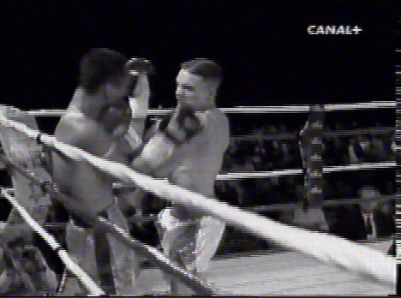 | 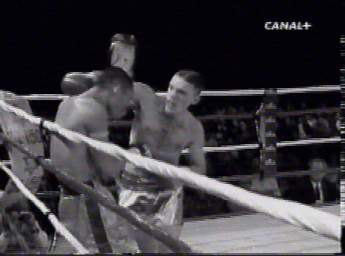 | 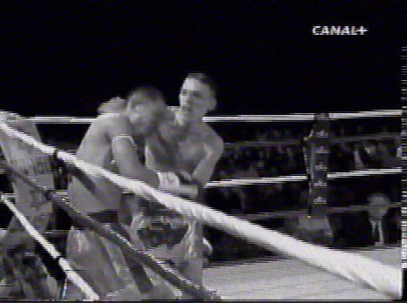
Skarbowski caught Robert Garnorasing cold early in the first round with a series of punches, including an uppercut and crunching right cross. The Thai was caught as the two fighters exchanged, both looking eager to extinguish each other’s confidence.
Jean Charles is one of Europe's top fighters currently and riding on the crest of a wave of a high percentage wins over top quality Thai’s on their home soil.
This quick win sets up a rematch in Thailand on the Kings Birthday show in front of 200,000 fans.
I've seen Robert fight for many years now and, and he will certainly be looking for revenge against Skarbowski, and I expect the outcome to be certainly a longer fight than this one turned out to be. (Also worth pointing out that had the fight been in Thailand or the referee had been, how can I say... more of a Thai boxing referee, the fight wouldn't have been stopped when it was).
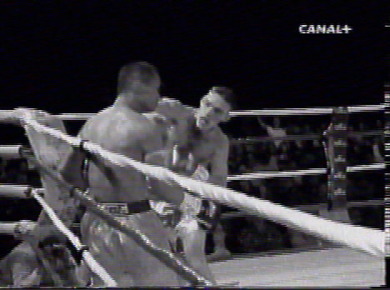 | 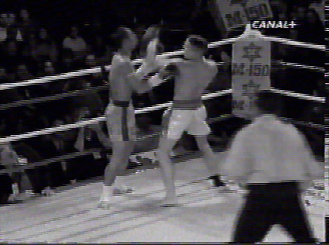 | 